**Project Design Phase-II**

**Data Flow Diagram & User Stories**

|  |  |
| --- | --- |
| **Date** | **28 October 2022** |
| **Team ID** | **PNT2022TMID33113** |
| **Project Name** | **AI - powered Nutrition Analyzer for Fitness Enthusiasts** |
| **Maximum Marks** | **4 Marks** |

**Data Flow Diagrams:**



Shipment

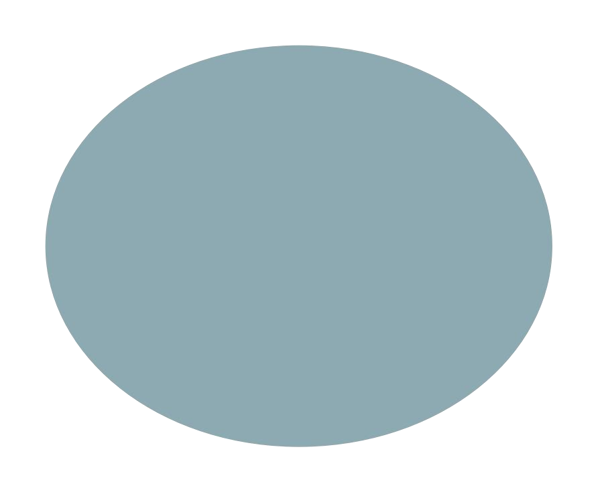

Rewards

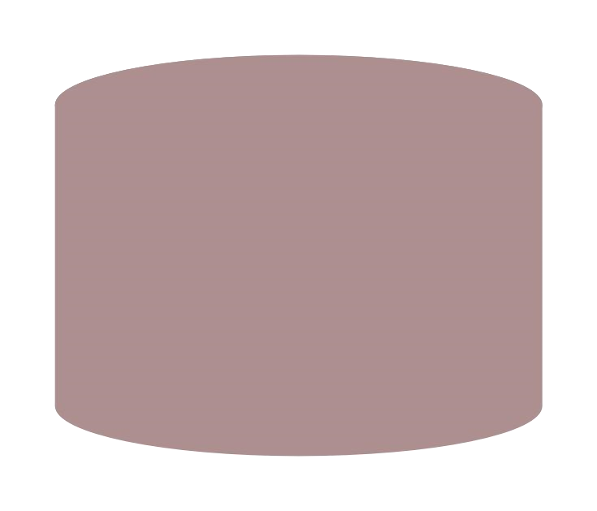

App

Database



Nutrion

Powder

order



Claiming

orders



Fitness



Daily

Task&tips



User



Register



Login



Upload image



Model



Variety

of

diet

charts



Diet

charts

|  |  |  |  |  |  |  |
| --- | --- | --- | --- | --- | --- | --- |
| **User Type** | **Functional**  **Requirement (Epic)** | **User**  **Story**  **Number** | **User Story / Task** | **Acceptance criteria** | **Priority** | **Release** |
| Customer (Web  user) | Dashboard | USN-3 | As a user, I can see the home page of the website of the nutrition analyzer | I can register & access the dashboard | Low | Sprint-3 |
|  |  | USN-4 | As a user, I can input image of food in the upload field | I can access the upload field without any problem. | Low | Sprint-3 |
| Administrator | Prediction | USN-1 | Here the model will be created and it predict the image using deep learning  Algorithms such as CNN. | In this I can have correct prediction on the particular algorithms. | High | Sprint-1 |
|  |  | USN-2 | The model is trained on the IBM cloud | In this the model is trained on the IBM cloud | Medium | Sprint-2 |
|  | Classifier | USN-5 | Here I will send all the model outputs to classifier in order to produce final results. | In this I will find the correct answers for producing the results. | Low | Sprint-4 |